Accessibility Action Plan

2021 – 2025

Acknowledgement of Country
GOTAFE acknowledges the Traditional Custodians of the Lands on which its campuses are situated, the Yorta Yorta, Bangerang, Taungurung and the Wurundjeri peoples, whose social, spiritual, economic, and cultural connections continue to flourish.

GOTAFE pays respect to all Elders past, present and emerging, and extends respect to all Indigenous peoples studying throughout its campus locations.

It is important this Action Plan is intersectional in its approach and meets the needs of all people with disability, including Aboriginal and Torres Strait Islander peoples.

Foreword
We are proud to commit to work embedded in the Social Justice Charter to ensure the GOTAFE experience is inclusive and welcoming for everybody, especially for people with barriers.

We have listened to our community and developed an Accessibility Action Plan which seeks to improve accessibility and address systemic barriers to ensure the full participation of people with disability.

This plan will ensure all students and staff with disability are provided equal opportunities and will remind us to celebrate the diversity within our staff and student body.

GOTAFE is accountable for bringing this action plan to life, including all 20 actions we have committed to. We have seen much positive progress in accessibility and inclusion and look forward to further improvements over the next four years.

Travis Heeney
GOTAFE CEO
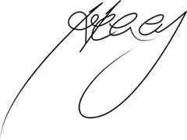

Introduction
GOTAFE has committed to Disability Action Plans since 2004. Since the first iteration, GOTAFE has transformed the accessibility of facilities, technology and improved organisational culture. In 2020, GOTAFE released a Social Justice Charter – articulating an organisational commitment to embed the principles of equity, fairness, and respect across GOTAFE and create equal opportunities for all students, staff, teachers, trainers and community. The Social Justice Charter commits to addressing barriers for several priority groups, including people with disability. It is this ethos that the GOTAFE Accessibility Action Plan 2021 – 2025 has been developed.

This action plan commits to going above and beyond minimum legislative requirements of both State and Federal Governments. GOTAFE is deeply committed to meeting the needs of its staff and students with disability, by making educational and workplace adjustments where required to ensure full participation in education and in work. GOTAFE strives to create an environment where all people can be their true selves, leaving nothing behind. We have committed to being an inclusive organisation, doing so by meeting the Victorian Public Sector employment target of recruiting 12 per cent of people with disability by 2025.

Disability and the GOTAFE community
Nearly one in five Australians have disability. In 2018, there were 4.4 million Australians identifying with disability, a total of 17.7 per cent of the population1. At GOTAFE, the number of students identifying with disability has been increasing. From 2018 to 2021, the proportion of students identifying their disability to GOTAFE increased from 9.6 per cent to 12.4 per cent. According to the 2021 People Matter Survey, 9 per cent of GOTAFE staff identify as having disability, however this is far lower according to the organisation’s diversity data, where only 4.1 per cent of staff identify with disability.

GOTAFE recognises there are barriers to sharing information, including actual or perceived threats of discrimination. GOTAFE will continue to work on improving disability awareness and inclusion so that staff and students are more disability confident, and people with disability are empowered to share their need for educational and workplace adjustments.

What do we mean by disability?
GOTAFE deliberately adopts the social model of disability, rather than the medical model, therefore adopting the United Nations definition proposed by the Convention on the Rights of Persons with Disability, whereby:

Persons with disability include those who have long-term physical, mental, intellectual, or sensory impairments which in interaction with various barriers may hinder their full and effective participation in society on an equal basis with others.

This definition means GOTAFE is focused on addressing barriers rather than an individual’s disability. Disability can be temporary or permanent, invisible, or visible and present itself from birth or at any time in someone’s lifetime.

Legislative and Policy Considerations

Disability Discrimination Act 1992 (Cth)
The Disability Discrimination Act 1992 (Cth) is a federal law that aims to:
- Eliminate discrimination against people with disability
- Promote community acceptance that people with disability have the same rights and
- Ensure, as far as practicable that people with disability have the same rights before the law.

Discrimination based on a person’s disability is unlawful, and occurs when:
- The person is treated less favourably than other person because of their disability (direct discrimination)
- The person is made to comply with a requirement that they cannot comply with due to their disability, resulting in disadvantage (indirect discrimination).

GOTAFE, in adhering to the principles within the Disability Discrimination Act 1992 (Cth), commits to inclusive employment, education, premises access and the provision of goods and services.

Disability Act 2006 (Vic)
The Disability Act 2006 (Vic) requires public sector bodies to prepare a Disability Action Plan that commits to inclusive delivery of information, services, facilities, employment, and complaints processes. The Act also expects that GOTAFE will promote the inclusion and participation of people with disability, including a change in attitudes and practices.

Equal Opportunity Act 2010 (Vic)
The Equal Opportunity Act 2010 (Vic) protects people from discrimination, sexual harassment, and victimisation, based on protected attributes, which includes disability. The Act also allows organisations to take positive steps to help disadvantaged groups, by using special measures2.

TAFE VET Funding Contracts
The TAFE VET Funding Contract specifies that ‘Trainer Providers must ensure that all learning materials for online training and assessment delivery comply with the principles of the Web Content Accessibility Guidelines 2.0.’

Consultation
GOTAFE is committed to hearing from diverse voices and as part of putting together this plan ran three consultation sessions attended by:

- Students with disability including past alumni and present students completing a range of different courses and accessing a range of different services.
- Community organisations, including Councils, advocacy organisations, specialist schools, disability employment services, health organisations and other TAFEs.
- GOTAFE staff with disability and allies, representing People and Culture, Student Success, Student Attraction, Trainers and Assessors, Marketing, Education Quality and GOTAFE Leadership.

Consultation Workshops
GOTAFE partnered with the Australian Network on Disability for the consultation process and utilised the framework articulated in the GOTAFE Social Justice Charter to categorise feedback into five key focus areas. Feedback was as follows:

Policy
- Improvement of reasonable adjustments process for students throughout their journey to improve information flow, control and informal options for students who do not formally identify with disability.
- Partnerships to facilitate employment and study pathways, including traineeships and apprenticeships with employers and tertiary education providers.
- Pathways from local high schools, including specialist schools into tertiary education, including transition, application, and enrolment support.
- Commitment to the Victorian Government Accessibility Guidelines and WCAG 2.1 AAA for digital accessibility and communications.
- Accessibility requirements to be built into procurement policies and activities across GOTAFE.
- Provision of inclusive recruitment training to panel members prior to them sitting on recruitment processes.

Infrastructure
- Additional accessible bathrooms and automated doors in new build and refurbishment plans and a move to improved lighting and flexibility with classroom setup.
- A focus on accessible pathways, especially from accessible parking spaces and ensuring reliability of lifts.
- Improvement of visibility and accessibility of signage of facilities and ensure location of relevant support services in quiet and private areas of campus.
- More flexible access to areas of campus for study usage.

Education
- Mandatory disability awareness training for staff including information on reasonable adjustments and accessible content.
- Provide training that incorporates awareness of mental health to GOTAFE staff.
- Upskilling frontline staff in welcoming visitors and students with disability.

Learning and Teaching
- Focus on more accessible, flexible, and inclusive learning delivery solutions, assistive technologies and access to laptops.
- Looking at pathways from specialist school to employment with programs such as the Certificate I in Work Education.
- Explore and promote more accessible and affordable student supports, including Auslan and learning hubs with access to student support staff.
- Focus on employability skills training for students, including mock interviews and resume writing skills.
- Discrete support system for people with invisible disability, for example the Sunflower Lanyard Scheme.

Celebration and Awareness
- Delivering a storytelling series to demonstrate the skills, abilities and successes of current and past students with disability.
- Collaborate with community organisations to co-design International Day for People with Disability activities.
- Ensuring all events are universally accessible by including appropriate supports and asking all attendees for adjustment requirements.

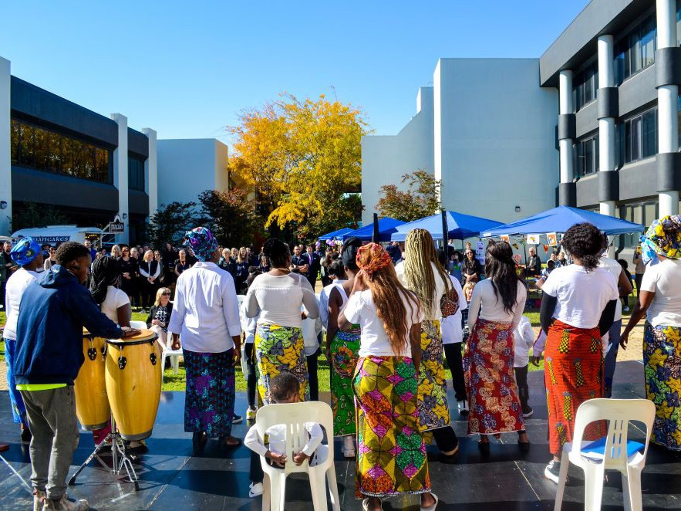
Access and Inclusion Index
The outputs from the consultation process were shared with relevant Directors, who also went through a process of self-assessing their work areas against the Access and Inclusion Index Comprehensive Self-Assessment. The Access and Inclusion Index is Australia’s foremost benchmarking tool for inclusion of people with disability. It measures an organisations performance against 10 criteria important for accessibility for people with disability.

There are four levels that an organisation can measure itself against for each criterion: not participating, basic, programmatic, or strategic. GOTAFE will use the Access and Inclusion Index to measure performance against the Accessibility Action Plan and commit to submitting to the Index to do so. In the meantime, GOTAFE has made self-assessed performance against the 10 criteria as follows:

Criteria number | Criteria Name | Maturity rating average | Maturity level
1 | Commitment | 2.8 | Basic
2 | Premises | 2.0 | Basic
3 | Workplace Adjustments | 1.4 | Foundational
4 | Communication and Marketing | 2.5 | Basic
5 | Products and Services | 2.5 | Basic
6 | Information Communication Technology (ICT) | 2.0 | Basic
7 | Recruitment and Selection | 1.8 | Foundational
8 | Career Development | 1.7 | Foundational
9 | Suppliers and Partners | 1.2 | Foundational
10 | Innovation | 2.0 | Basic

This exercise, although not endorsed by the Australian Network on Disability, is useful for determining key focus areas of the plan. The organisation met minimum expectations on commitment, communications and services due to our Social Justice Charter, and focus on accessibility by various teams across GOTAFE. However, the above informs GOTAFE of a need to focus on People and Culture and Procurement.

Overall, it is hoped that during this Accessibility Action Plan, GOTAFE will move to a maturity level of programmatic and that this will be acknowledged through the official Access and Inclusion Index submission.

Action Plan
After considering the feedback received from consultation workshops and measuring ourselves against good practice in the Access and Inclusion Index, GOTAFE has committed to the following action. Some actions will help us achieve our vision set out in the GOTAFE Social Justice Charter, while others will help GOTAFE respond to the Victorian Government Inquiry into Access to TAFE for Learners with Disability.

GOTAFE has appointed Cameron Cahill as the GOTAFE Executive Champion for disability. Cameron’s role is to keep Accessibility and the inclusion of people with disability on the Executive agenda and advocating for action amongst responsible action owners. Cameron has a unique opportunity to influence and engage staff and students with disability as well as community engagements.

Review
Progress on actions contained within the Accessibility Action Plan will be reported to the GOTAFE Board and Executive at least annually, with a view to refining actions as considerable progress is made. The GOTAFE Annual Report will include a section on progress of meeting expectations set by the Accessibility Action Plan.

To measure progress, the Access and Inclusion Index will be used, with a formal submission to the Australian Network on Disability. This will be our evidence base to show improvement in accessibility and inclusion of people with disability at GOTAFE.

Policy – focuses on organisational-wide social justice directives

Action | Performance Indicator | Responsible
Publicly commit to the recruitment of more staff with disability through the standard recruitment process and discrete disability employment programs. | Increased % of staff with disability;  % of jobs advertised to disability platforms; number of staff with disability employed through discrete programs. | People and Culture
Create GOTAFE Enablers Network for staff with disability and allies to contribute to disability inclusion. | Network formed; purpose defined; number of meetings held. | Strategy and Governance
Develop an Adjustments Policy and an Adjustments Passport for staff. | Adjustments policy finalised; policy communicated to staff; adjustment passport available to staff; central funding mechanism. | People and Culture
Partner with JobAccess to review recruitment, induction, flexibility, and adjustment policies. | Partnership commenced; policies reviewed and updated. | People and Culture
Continue membership with the Australian Network on Disability and participate in membership activities. | Submit Access and Inclusion Index; participate in other programs. | Strategy and Governance
Commitment to meeting WCAG  2.1 AAA in internet, intranet, and relevant applications, including Learning Management System. | % of applications meeting WCAG  2.1 AAA and Victorian Government Accessibility Guidelines; user testing with people with lived experience. | Digital Solutions / Education Resources
Commit to accessibility requirements in procurement policy and process. | Accessibility embedded in procurement policy; accessibility built into requirements for products and services procured; | Finance and Procurement
Commit to integrating accessibility requirements in current communications and marketing policies. | Communications (internal and external) checked for accessibility. | Communications and Engagement

Infrastructure – focuses on the physical aspects of GOTAFE and providing accessible, safe, and appropriate spaces

Action | Performance Indicator | Responsible
Accessibility audit of campus footprint to identify areas for improvement. | No. of campuses reviewed for accessibility. | Assets and Facilities
Apply Design for Dignity principles to new and refurbish builds, going beyond minimum compliance. | % of GOTAFE buildings meeting minimum accessibility compliance;  % new and refurbish builds utilising principles via master planning process. | Assets and Facilities
Improve accessibility features including accessible wayfinding, mobility charging stations and provision of quiet spaces. | % of campuses with accessible wayfinding, mobility charging stations and a quiet room. | Assets and Facilities

Education – focuses on staff, teachers and trainers providing support for students and each other

Action | Performance Indicator | Responsible
Conduct disability awareness training to upskill employees to be disability confident with a focus on adjustments and accessibility. | % of staff trained (in person or virtual). | People and Culture
Continue mental health first aid training and increase number of staff trained. | 50% of staff trained by end of the plan. | People and Culture

Learning and Teaching – focuses on students and their experiences at GOTAFE

Action | Performance Indicator | Responsible
Develop resources on sharing disability and adjustments and follow up with students regarding available supports. Improving data collection for students and staff in line with this. | Resource developed; No. of students contacted and engaged; adjustment passport available to students. | Student Attraction and Enrolment / Student Success
Targeted attraction of students with disability through event attendance and outreach programs. | No. of events attended and outreach programs; increase % of students with disability. | Student Attraction and Enrolment
Add to scope Certificate in Work Education, providing pathways from school to employment for students with disability. | Business case for adding to scope completed; at least one disability specific course added to scope. | Foundations and Futures
Seek opportunities to partner with social enterprises to run on-campus services, training students for employability. | Opportunities for collaboration scoped; partnership formed. | Education / Attraction and Engagement
Join TAFE Specialist Employment Partnership program. | Increase % of students with disability achieving employment outcomes. | Student Attraction and Enrolment / Student Success

Celebration and Awareness – focuses on building awareness of social justice through targeted communication and providing opportunities for people and communities to connect.

Action | Performance Indicator | Responsible
Ensure all events are accessible for people with disability. | % of event accessibility for people with disability; % student and staff satisfaction. | Communications and Engagement
Co design International Day of People with Disability and RUOK? Day celebration annually. | Number of events ran at several GOTAFE campuses. | Communications and Engagement

1300 GOTAFE (468 233)
gotafe.vic.edu.au
RTO 3094

